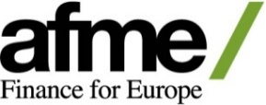 | 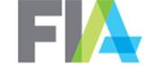 |  | 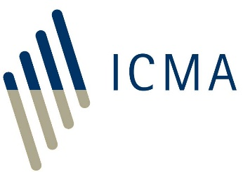
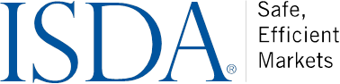 |  | 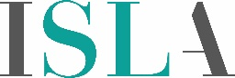

NEWS RELEASE
For Immediate Release

AFME, FIA, ICMA, ISDA and ISLA Publish
Master Regulatory Reporting Agreement

NEW YORK & LONDON, December 19, 2019 – The Association of Financial Markets in Europe (AFME), Futures Industry Association (FIA), International Capital Market Association (ICMA), International Swaps and Derivatives Association, Inc. (ISDA) and International Securities Lending Association (ISLA) have published a new agreement intended to simplify reporting across different European Union regulatory regimes.

The Master Regulatory Reporting Agreement (MRRA) gives market participants an option to use a single template to help them manage regulatory obligations and provide services related to reporting under the European Market Infrastructure Regulation (EMIR) and the Securities Financing Transactions Regulation (SFTR). Use of a common template for all reporting relationships under the two rule sets will bring greater efficiency and consistency to the regulatory reporting process.

The MRRA sets out common terms governing mandatory and delegated reporting of derivatives transactions under EMIR, compatible with changes introduced via EMIR Refit, as well as securities financing transactions under the SFTR. The agreement has also been drafted with a view to ensuring these terms remain effective post-Brexit.

The MRRA was developed with the assistance of committees and working groups established by AFME, FIA, ICMA, ISDA and ISLA, comprising representatives from both buy- and sell-side firms with expertise in derivatives and securities financing transactions.

The MRRA and an explanatory memorandum setting out the architecture and background to the MRRA is available here.

For Press Queries, Please Contact:
Nick Sawyer, ISDA, +44 20 3808 9740, nsawyer@isda.org
Christopher Faimali, ISDA, +44 20 3808 9736, cfaimali@isda.org
Rebecca Hansford, AFME, +44 20 3828 2693, rebecca.hansford@afme.eu
Steven Adamske, FIA, +1 202 772 3008, sadamske@fia.org
Allan Malvar, ICMA, +44 20 7213 0322, allan.malvar@icmagroup.org
Margaret Wilkinson, ICMA, +44 20 7213 0323, margaret.wilkinson@icmagroup.org
Sejal Amin, ISLA, +44 20 3786 2367, sejal.amin@isla.co.uk

About ISDA
Since 1985, ISDA has worked to make the global derivatives markets safer and more efficient. Today, ISDA has more than 900 member institutions from 71 countries. These members comprise a broad range of derivatives market participants, including corporations, investment managers, government and supranational entities, insurance companies, energy and commodities firms, and international and regional banks. In addition to market participants, members also include key components of the derivatives market infrastructure, such as exchanges, intermediaries, clearing houses and repositories, as well as law firms, accounting firms and other service providers. Information about ISDA and its activities is available on the Association’s website: www.isda.org. Follow us on Twitter @ISDA.

ISDA® is a registered trademark of the International Swaps and Derivatives Association, Inc.

About AFME
AFME (Association for Financial Markets in Europe) advocates for deep and integrated European capital markets that serve the needs of companies and investors, supporting economic growth and benefiting society. AFME is the voice of all Europe’s wholesale financial markets, providing expertise across a broad range of regulatory and capital markets issues. AFME aims to act as a bridge between market participants and policy makers across Europe, drawing on its strong and long-standing relationships, its technical knowledge and fact-based work. Its members comprise pan-EU and global banks as well as key regional banks, brokers, law firms, investors and other financial market participants. AFME participates in a global alliance with the Securities Industry and Financial Markets Association (SIFMA) in the US, and the Asia Securities Industry and Financial Markets Association (ASIFMA) through the GFMA (Global Financial Markets Association). For more information please visit the AFME website: www.afme.eu. Follow us on Twitter @AFME_EU

About FIA
FIA is the leading global trade organization for the futures, options and centrally cleared derivatives markets, with offices in Brussels, London, Singapore and Washington, D.C. FIA’s membership includes clearing firms, exchanges, clearinghouses, trading firms and commodities specialists from more than 48 countries as well as technology vendors, lawyers and other professionals serving the industry. FIA’s mission is to support open, transparent and competitive markets, protect and enhance the integrity of the financial system, and promote high standards of professional conduct. As the principal members of derivatives clearinghouses worldwide, FIA’s member firms play a critical role in the reduction of systemic risk in global financial markets.

About ICMA
ICMA is the trade association for the international capital market with over 580 member firms from 60 countries, including banks, issuers, asset managers, infrastructure providers and law firms. It performs a crucial central role in the market by providing industry-driven standards and recommendations for issuance, trading and settlement in international fixed income and related instruments. ICMA liaises closely with regulatory and governmental authorities, both at the national and supranational level, helping to ensure that financial regulation promotes the efficiency and cost effectiveness of the capital market. www.icmagroup.org

About ISLA
International Securities Lending Association (ISLA) is a leading industry association, representing the common interests of securities lending and financing market participants across Europe, Middle East and Africa. Its geographically diverse membership of over 160 firms, includes institutional investors, asset managers, custodial banks, prime brokers and service providers. Working closely with the global industry as well as regulators and policy makers, ISLA advocates the importance of securities lending to the broader financial services industry. ISLA supports the development of a safe and efficient framework for the industry, by playing a pivotal role in promoting market best practice, amongst other things. ISLA sponsors the Global Market Securities Lending Agreement (GMSLA) and the annual enforceability review in over 20 jurisdictions globally. Through member working groups, industry guidance, consultations and first-class events and education, ISLA helps to steer the direction of the industry and is one of its most influential voices on the European and global stage.

